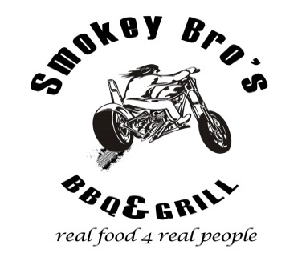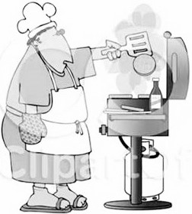
1st annual Smokey Bro’s, “Feed our Kids” Amateur BBQ Contest
Partnered with Denham Ford, Summitt107 FM, OK Tire & Brothers Insurance

Raising monies to support the Salvation Army’s Cranbrook & Kimberley School Lunch Program

Every school year there are less fortunate children attending our local schools right here in our own backyards that do not even have a basic lunch to eat while at school!!!
Annually the Salvation Army in Cranbrook delivers a staggering 20,000 lunches to schools in Cranbrook and Kimberley for local children that otherwise would not have a lunch to eat!!!!
We are asking local businesses to help us support this great cause by donating monies, product or services towards this worthy cause.
On June 4th at Smokey Bro’s Food Truck (in the Harley Davidson parking lot) we will be holding an Amateur Grill Master contest, where local backyard BBQ Artistes’ can let their BBQ skills go wild and showcase their hidden talents.
There will be complete outdoor bbq kitchens set up along with a pantry full of food selections and tools to help them produce some culinary delights that will then be judged by a panel of celebrity guest judges.
The winner will be awarded a prize and the acclimation of being the Cranbrook/Kimberley
Amateur 2016 “Grill Master”!!

Please join the growing list of sponsors in this great fundraising event and help us so that no kids go hungry at our schools. Together we can make a difference.

Thanking you for your time, support and consideration

